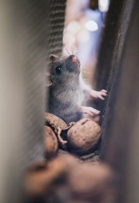
Of Mice And Men – John Steinbeck
Questions - SOLUTION
Chapter 1-4
1 own answers
2 a) puppy, rabbit, mouse b) bastard c) bunkhouse d) scared e) ketchup
3 a) chase b) alone c) trouble d) demand e) feed f) pet g) body
4 - land means “Boden” – The table will be full of food, the land will give you everything; you don’t have to work that hard- just 6-7 hours a day; you’ll be happy
5 George is small and clever. Lennie is tall, strong and mentally handicapped.
6 a) There was trouble in Weeds and they were chased out of town.
b) Because Lennie is a little bit slow in the head and then they won’t get the job.
c) Because he hates big and strong men.
d) He is afraid of Curley because he is a dangerous man.
e) Curley’s wife is a dangerous and wild woman.

Chapter 5- 8
7 a) Lennie wants to leave the farm, because he is afraid of Curley.
b) Candy is happy to work there.
c) Curley’s wife is unhappy because she is married to the boss’ son.
8 a) clothes b) clothes c) hand
9) a) Yes – to buy an own farm; b) No – they could get into trouble c) Yes – they want to have chicken, rabbits and vegetables d) No – they don’t want to lose their job
10) a) George b) Candy c) Slim d) Lennie
11) a) Candy b) Candy & George c) Curley d) Crooks e) Slim

Chapter 9-11
12) own answer
13) schütteln
14) a) Because they will get into trouble with Curley.
b) He throws the puppy on the ground, because it is dead. He is angry.
c) He wants her to be quiet.
15) own answer

Writing
own answers

