Klasse 3a
18.03. – 03.04.2020 name:
 | tasks | material
1 | Correct your crazy invention text or write the missing text into your N&E book or on a sheet of paper. | WS, N&E book, sheet
2 | If you have your Check book correct all your checks. Don’t forget the signature of one of your parents and mark your percentage on the first page. | Check book
3 | Vocabulary Unit 9: WB p.74/ Word File  Write down the teen activities into your Notes & Exercise book or on a sheet of paper and translate them into German. | WB  N&E book, sheet
4 | Unit 9: Young people today  - SB p.92/1, 2; p.93/3, 4  If you download the MORE! Media App (MORE! 3 General Course Student’s Book / Workbook) you can listen to the texts. If you didn’t know that yet, have a look at the front page (Cover Innenseite oben). 😊  - SB p.96/10: vocabulary exercise  Check the exercises with the solution paper.  - WS: What are you allowed to do?  Interview three of your classmates. Send them a text message. Choose a headline and write a text with the results into your N&E book or on a sheet of paper. | SB  MORE! Media App  SB  solution paper  WS  N&E book, sheet
5 | WB exercises:  Do the exercises on p.67, 68/1, 2; p.68/4, 5; p.71/15, 16; p.72/17, 18, 19 and check them with the solution paper.  Do all the missing exercises in your Workbook until Unit 8. You can check the rest later, when you have your WB solution papers. You will find the listening exercises in the MORE! Media App. Also have a look at the “Developing speaking competencies / Developing writing skills” at the end of every Unit. | WB  solution paper  MORE! Media App
6 | Essential English:  SB p.29/3; p.73/3, 4 (e.g. text message 😊); p.83/4 – check it with the solution paper  p.91/3, 4: Write a text about “My TV habits” into your N&E book or a sheet of paper. Use about 100 words. What do you (not) like watching? What’s your favourite programme / series / …? Why? Where? When? How long? How many hours a day? …  p.103/5: Use the questions and write a text about “My favourite clothes” into your N&E book or a sheet of paper. Use about 100 words. | SB, solution paper  N&E book, sheet
7 | WS: Comparatives and Superlatives of Adjectives  Fill in the chart and check it with the solution paper. | WS  solution paper
8 | WS: Frage nach dem unterstrichenen Satzteil (Past Tense, Present Tense) / Mache Verneinung und Frage  Do the exercises and check it with the solution paper. | WS  solution paper
9 | Englische Zeiten – Test:  Test yourself and do the exercises on different tenses. Check your answers with the solution paper.  https://www.englisch-hilfen.de/download/test_englische_zeiten_de.pdf | Link  solution paper
10 | Tenses: Put the sentences into the following tenses (+, ?, -). Write them into your N&E book or a sheet of paper. Don’t forget to check your sentences.  a) Henry (watch) TV. → Present Simple, Present Progressive, Past Simple, Present Perfect, Will – Future, Going to – Future  b) The dog (be) hungry. → Present Simple, Past Simple, Present Perfect, Will – Future, Going to – Future | N&E book, sheet  solution paper
11 | Learn the vocabulary: food and clothes on www.quizlet.com Suche: MissB19 – Nutzer anklicken  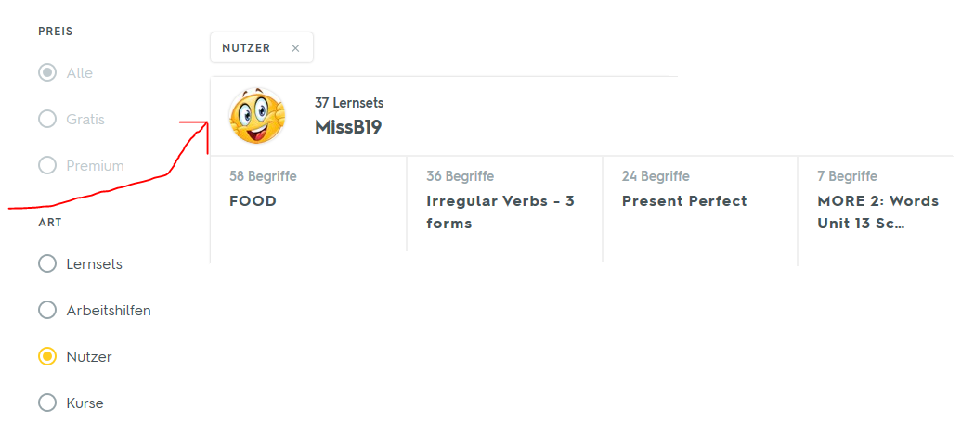  oder Suche z.B.: MORE3 Unit 9 (damit kannst du die WB-Vokabeln üben) | internet
12 | More exercises:  - Progress Checks (Units 1-4, 5-8), C.HWs from MORE!1, MORE!2, MORE!3  - The Big Challenge App or https://www.thebigchallenge.com/at/student/game-zone/  - MORE! Media App (MORE 3)  - https://learnenglishkids.britishcouncil.org/  - https://learnenglishteens.britishcouncil.org/

Have a good time and take care,
Miss B 😊 Mrs D 😊

!!! WICHTIG!!!:
Jeder hat per Edupage einen Zugangscode für das digitale SB und einen Zugangscode für das digitale WB erhalten. Wer seine Bücher hat, darf natürlich den Code, der hinten auf dem jeweiligen Buch steht, verwenden.

Arbeitsplan – SOLUTION PAPER

SB p.92/1: Milase is not allowed to go out when it is dark. Her parents were not allowed to speak Zulu at school.
SB p.92/2c: 1 South Africa., 2 two languages (English and Zulu)., 3 as a housewife., 4 in a small house., 5 at the weekends., 6 go out when it’s dark.
SB p.93/4: 1 F, 2 T, 3 T; 4 go hunting alone, 5 build an igloo / camp in an igloo, 6 in the winter; 7, 8, 9: own answers
SB p.96/10: 15, 3, 9, 1, 14, 8, 5, 11; 16, 6, 12, 4, 7, 13, 10, 2

WB exercises:
p.67/2: 1 is 2.6 million; 2 mechanic and a nurse; 3 in the bush; 4 T; 5 F; 6 F; 7 He felt something pulling on their tent. 8 They went out of the tent and ran to the car. 9 They saw a big crocodile that was pulling the tent into the river.
p.68/4: Peru, Bolivia, Brazil, Venezuela

p.68/5: 1 Raukani; 2 Agripina; 3 José; 4 Renato; 5 Raukani; 6 Renato; 7 José, 8 Agripina
p.71/15: 3, 6, 1, 5, 2, 4
p.71/16: Siehe SB p.96
p.72/17: -
p.72/18: 1 I could lend you some. 2 Why don’t I ask my brother to lend you his. 3 Would you like me to come with you? 4 Do you want me to ask my mum if you can have it here?
p.72/19: 1 Would you like me to come with you? 2 Why don’t I ask my brother to lend you his? 3 Do you want me to ask my mum if you can have it here? 4 I could lend you some.

SB p.29/3: 1 angry, 2 bored, 3 excited, 4 happy, 5 sad, 6 scared, 7 surprised, 8 nervous
SB p.73/3: 1 I’m going to watch, 2 I’d love to, 3 I’m going to meet, 4 She didn’t invite me
SB p.83/4: 1 Kevin, 2 Tom, 3 Paul, 4 Ben

Englische Zeiten – Test: Do you remember? – Tenses: 1 do; 2 went, bought; 3 have already finished;
4 was working, was cooking; 5 sleeps; 6 has just written; 7 has never had; 8 was sleeping; 9 are, is going to hail; 10 will come; 11 didn’t phone; 12 were; 13 haven’t seen; 14 are going / are going to go; 15 does; 16 is climbing; 17 have already done; 18 got; 19 will shout; 20 leaves

Tenses:
Henry watches TV. Does Henry watch TV? Henry doesn’t watch TV.
Henry is watching TV. Is Henry watching TV? Henry isn’t watching TV.
Henry watched TV. Did Henry watch TV? Henry didn’t watch TV.
Henry has watched TV. Has Henry watched TV? Henry hasn’t watched TV.
Henry will watch TV. Will Henry watch TV? Henry won’t watch TV.
Henry is going to watch. Is Henry going to watch TV? Tony isn’t going to watch TV.

The dog is hungry. Is the dog hungry? The dog isn’t hungry.
The dog was hungry. Was the dog hungry? The dog wasn’t hungry.
The dog has been hungry. Has the dog been hungry? The dog hasn’t been hungry.
The dog will be hungry. Will the dog be hungry? The dog won’t be hungry.
The dog is going to be hungry. Is the dog going to be hungry? The dog isn’t going to be hungry.

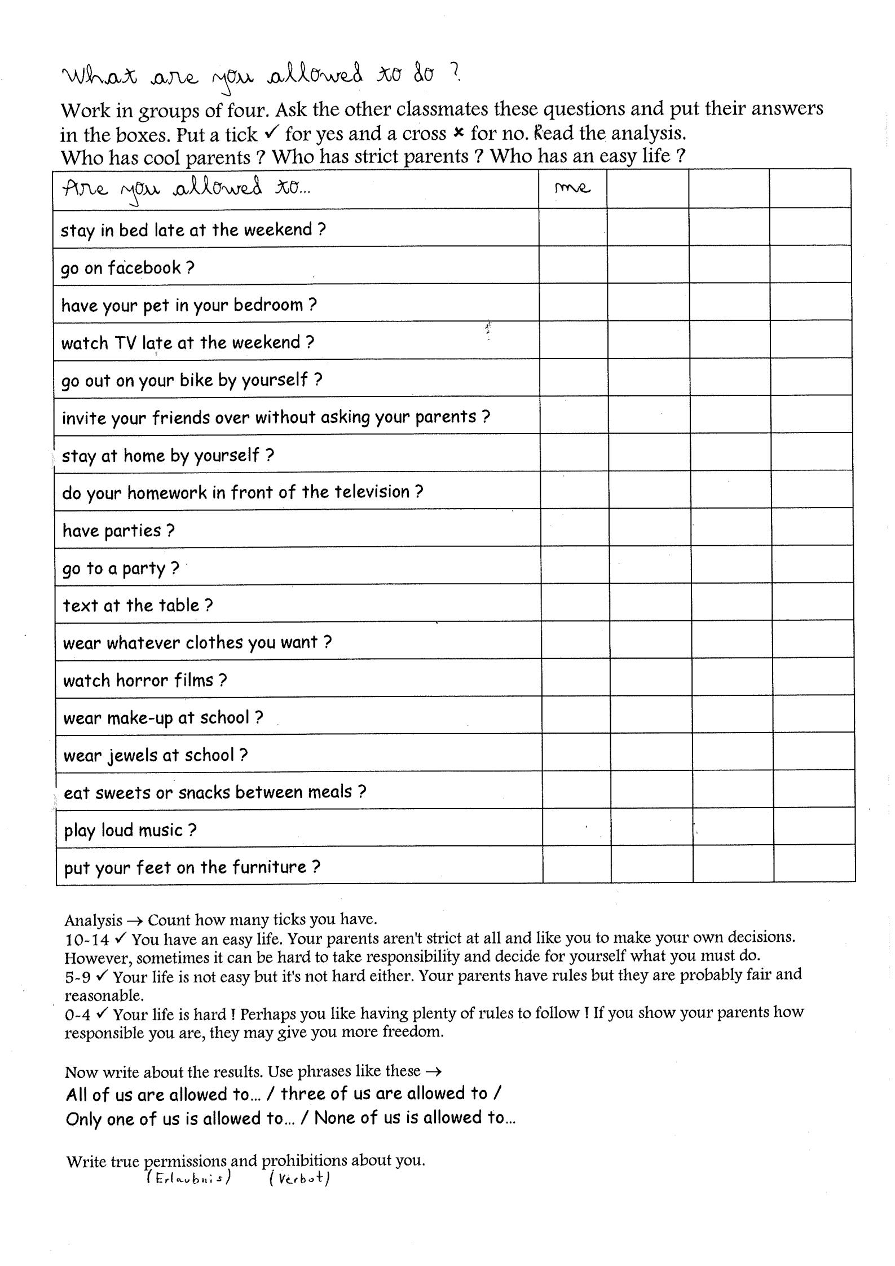
Comparatives and Superlatives of Adjectives
Write the comparative and superlative forms of the adjectives below.
example: big/bigger/biggest or important/more important/most important
Adjective | Comparative | Superlative | Adjective | Comparative | Superlative
1.tall |  |  | 22. far
2. cheap |  |  | 23. bad
3. expensive |  |  | 24. fat
4. good |  |  | 25. interesting
5. lazy |  |  | 26. narrow
6. pretty |  |  | 27. safe
7. beautiful |  |  | 28. dangerous
8. difficult |  |  | 29. messy
9. boring |  |  | 30. handsome
10. shy |  |  | 31. attractive
11. happy |  |  | 32. delicious
12. short |  |  | 33. useful
13. famous |  |  | 34. easy
14. comfortable |  |  | 35. lucky
15. ugly |  |  | 36. quiet
16. warm |  |  | 37. noisy
17. long |  |  | 38. modern
18. intelligent |  |  | 39. patient
19. wide |  |  | 40. convenient
20. thick |  |  | 41. accurate
21. smart

Comparatives and Superlatives of Adjectives

Write the comparative and superlative forms of the adjectives below.
example: big/bigger/biggest or important/more important/most important
Adjective | Comparative | Superlative | Adjective | Comparative | Superlative
1.tall | taller | the tallest | 22. far | farther | the farthest
2. cheap | cheaper | the cheapest | 23. bad | worse | the worst
3. expensive | more expensive | the most expensive | 24. fat | fatter | the fattest
4. good | better | the best | 25. interesting | more interesting | the most interesting
5. lazy | lazier | the laziest | 26. narrow | narrower | the narrowest
6. pretty | prettier | the prettiest | 27. safe | safer | the safest
7. beautiful | more beautiful | the most beautiful | 28. dangerous | more dangerous | the most dangerous
8. difficult | more difficult | the most difficult | 29. messy | messier | the messiest
9. boring | more boring | the most boring | 30. handsome | more handsome | the most handsome
10. shy | shyer | the shyest | 31. attractive | more attractive | the most attractive
11. happy | happier | the happiest | 32. delicious | more delicious | the most delicious
12. short | shorter | the shortest | 33. useful | more useful | the most useful
13. famous | more famous | the most famous | 34. easy | easier | the easiest
14. comfortable | more comfortable | the most comfortable | 35. lucky | luckier | the luckiest
15. ugly | uglier | the ugliest | 36. quiet | quieter | the quietest
16. warm | warmer | the warmest | 37. noisy | noisier | the noisiest
17. long | longer | the longest | 38. modern | more modern | the most modern
18. intelligent | more intelligent | the most intelligent | 39. patient | more patient | the most patient
19. wide | wider | the widest | 40. convenient | more convenient | the most convenient
20. thick | thicker | the thickest | 41. accurate | more accurate | the most accurate
21. smart | smarter | the smartest

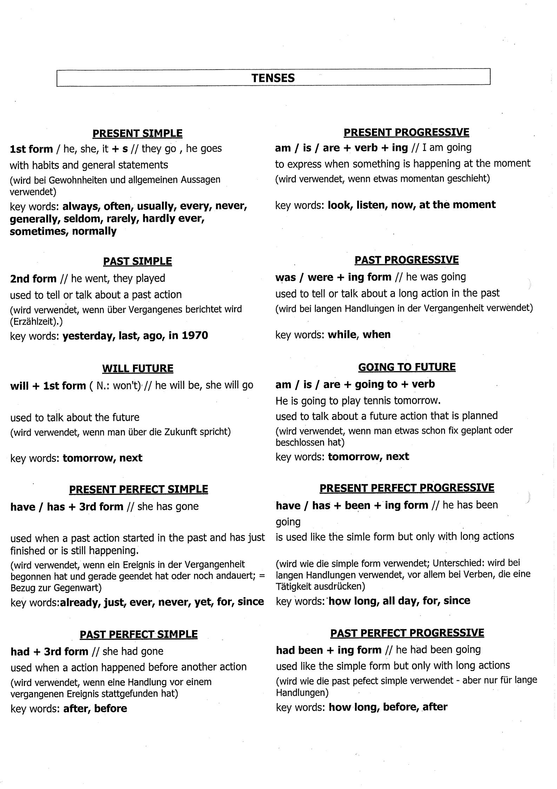
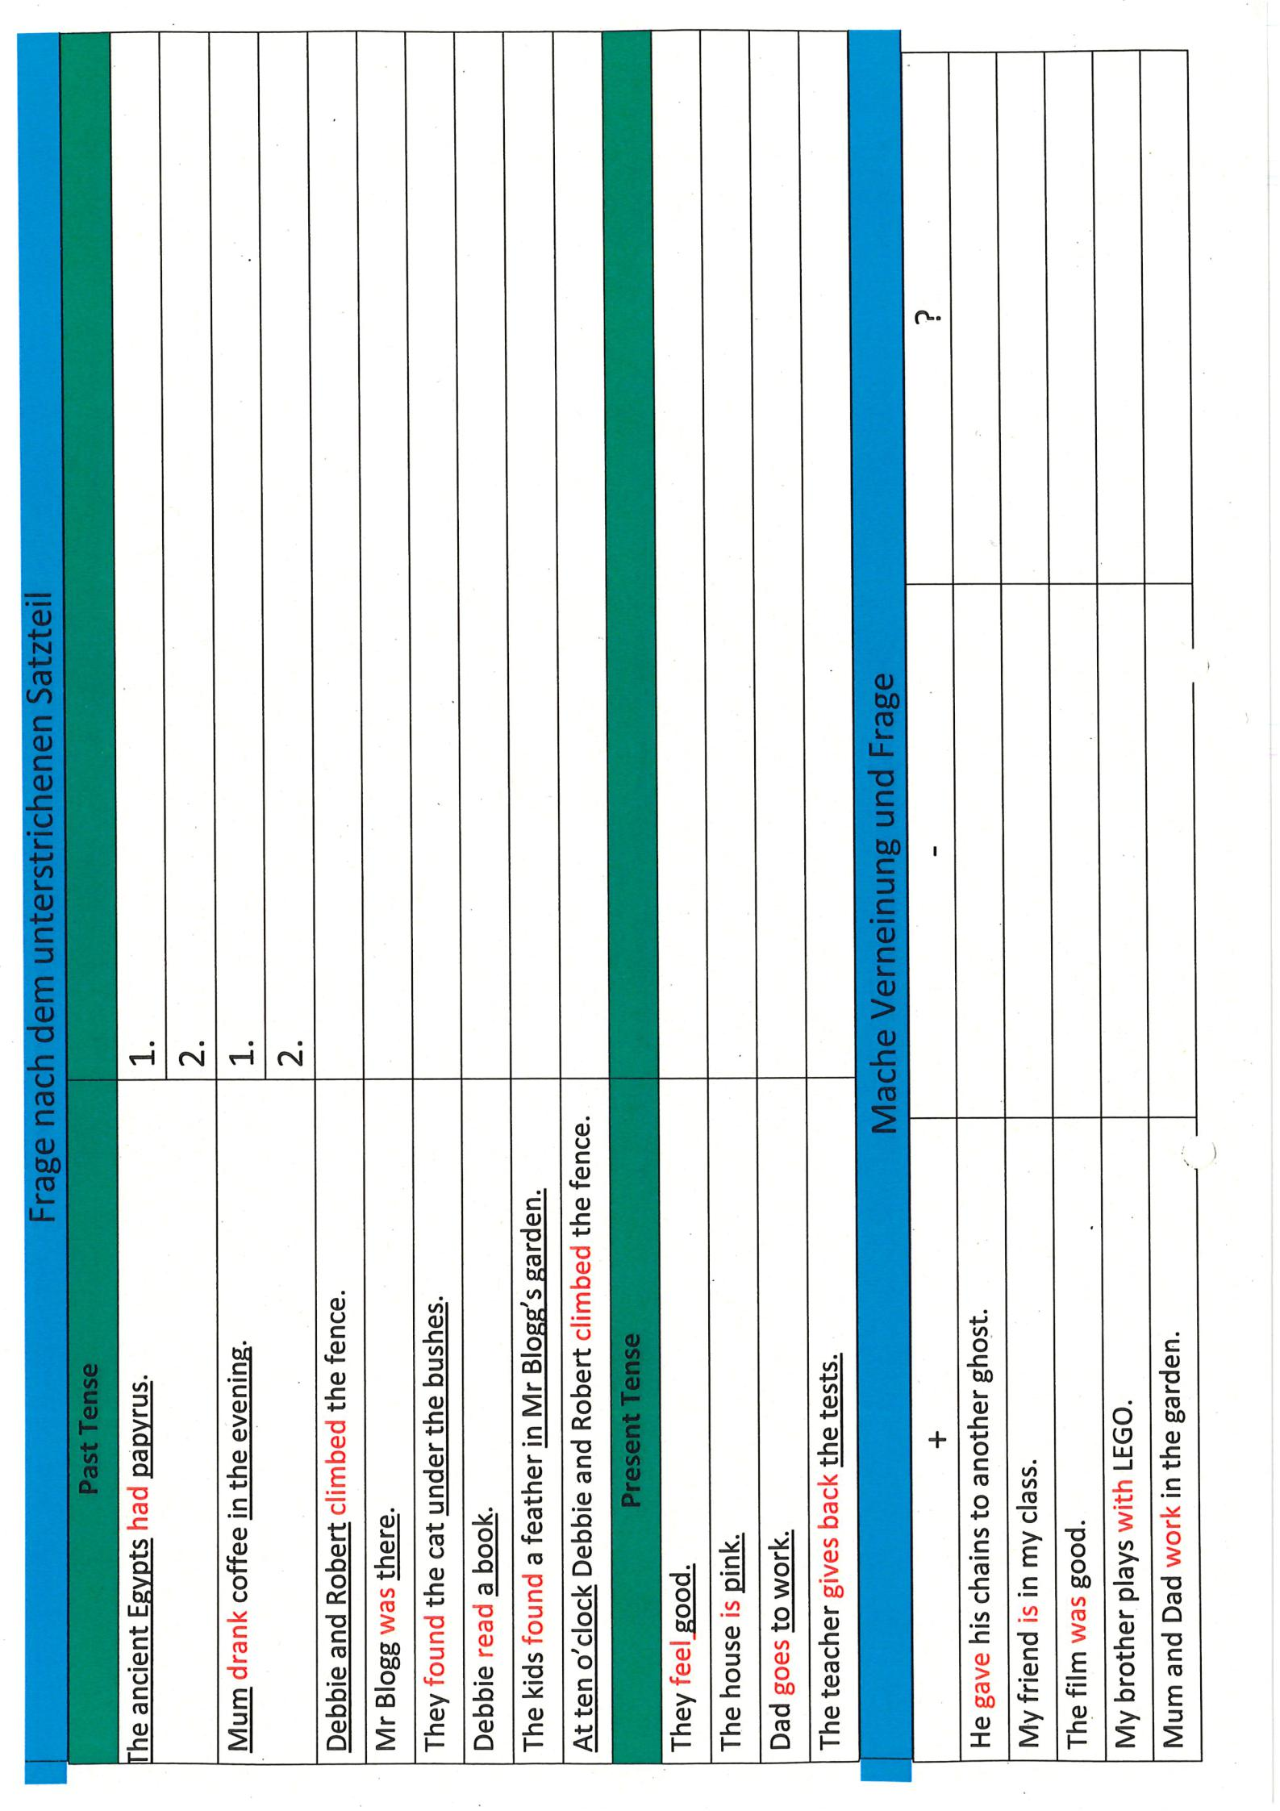
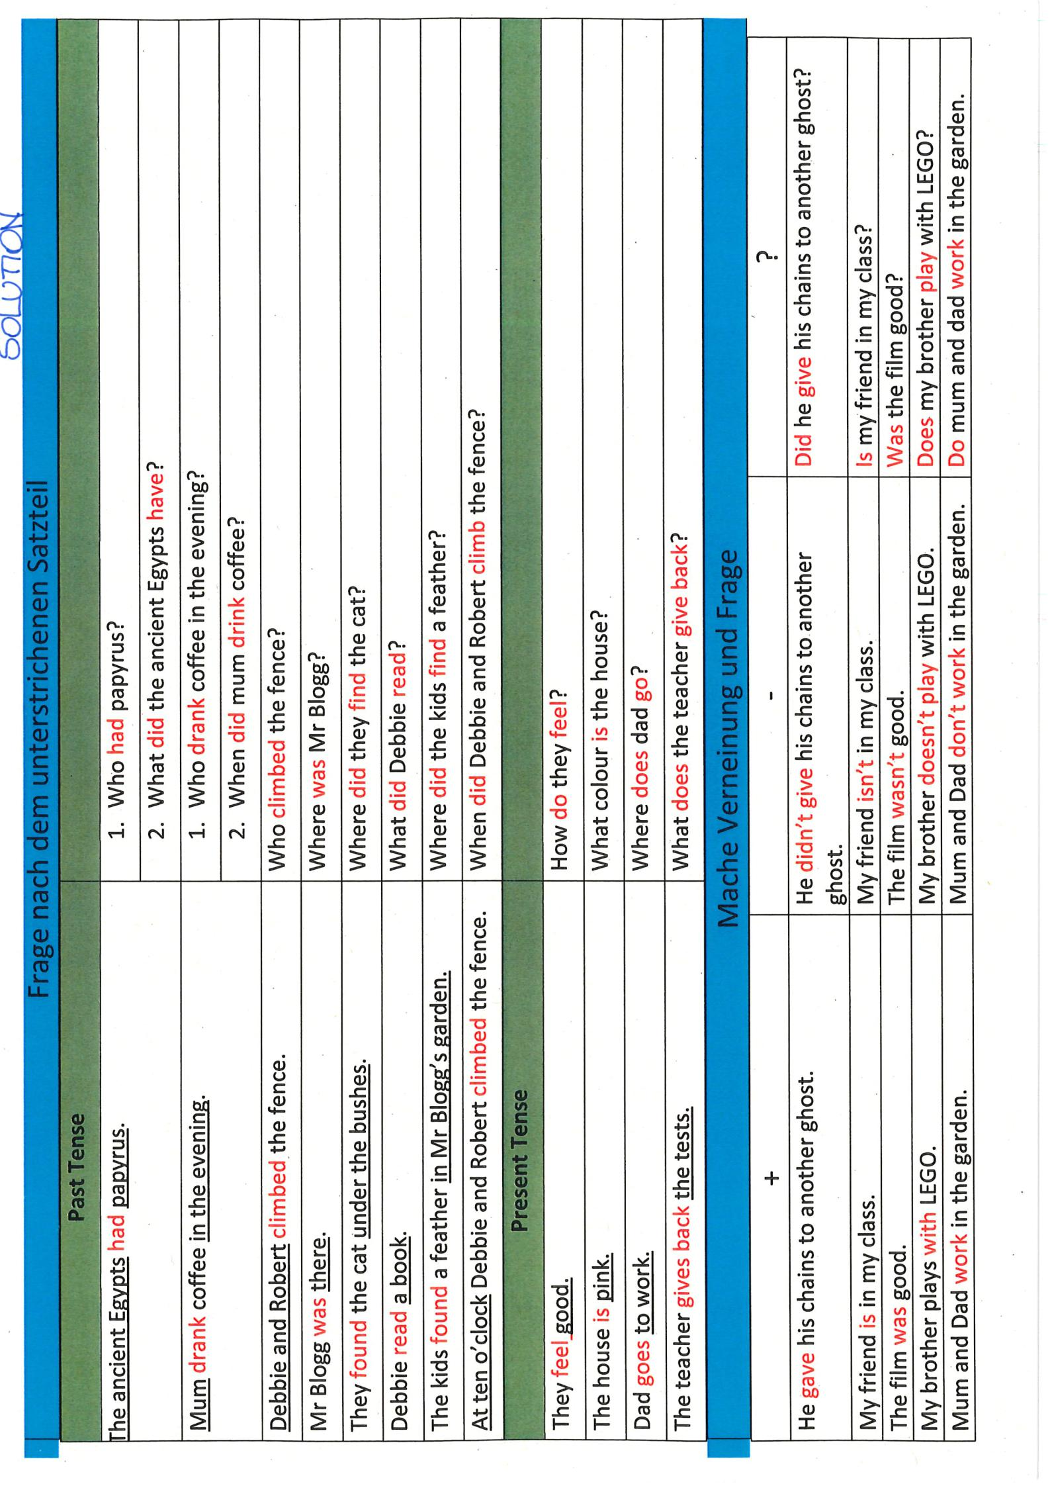

Englisch - Zeiten - Test

Exercise:
https://www.englisch-hilfen.de/download/test_englische_zeiten_de.pdf

Lösungen:
https://www.englisch-hilfen.de/download/test_englische_zeiten_de_loesung.pdf

